Order Of Service

Singing: Psalm 145—CW page 119

Reading: Psalm 63

Opening Hymn: TLH 128

Reading: Acts 7:30-34

Request Hymn: CW Supplement 769

Reading: John 15:1-17

Sermon Hymn: TLH 130

Sermon Text: Daniel 1:8-16

Pulse & Water

Prayer

The Apostles’ Creed, TLH page 12

Holy Communion

The Lord's Prayer

The Blessing

Closing Hymn: TLH 54

* * * * * * * * * * *

Bible Study: Lambs: Ice
Sheep: Romans 7:7-12
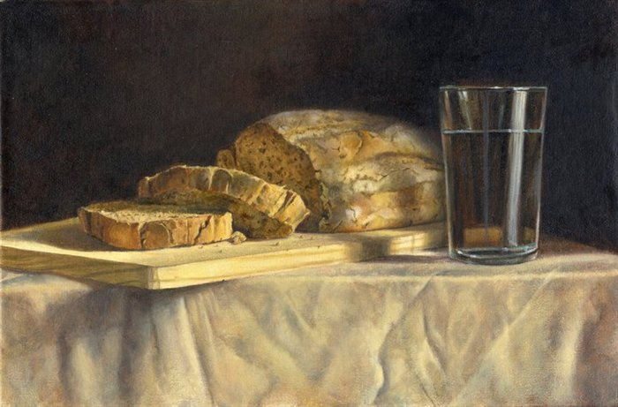

Our Daily Bread

Water
Of
Life

19 November 2017

W A T E R O F L I F E

Independent Christian Church—Conservative Lutheran Doctrine

Worship Service: 9:30 a.m. Bible Study: 10:45 a.m.

Larry Cooper, Pastor E-Mail address:
111 N. Ridge Road lcooper@wateroflife.cc
Coon Valley, WI 54623 Web Site:
Phone: (608) 452-2105 www.wateroflife.cc

* * * * * * * * * * * * * * * * * * * * * * * * * * *

Sermon Text: Daniel 1:8-16

Pulse & Water

* * * * * * * * * * * * * * * * * * * * * * * * * * *

Daniel 1:8 But Daniel purposed in his heart that he would not defile himself with the portion of the king's meat, nor with the wine which he drank: therefore he requested of the prince of the eunuchs that he might not defile himself.
:9 Now God had brought Daniel into favour and tender love with the prince of the eunuchs.
:10 And the prince of the eunuchs said unto Daniel, I fear my lord the king, who hath appointed your meat and your drink: for why should he see your faces worse liking than the children which are of your sort? then shall ye make me endanger my head to the king.
:11 Then said Daniel to Melzar, whom the prince of the eunuchs had set over Daniel, Hananiah, Mishael, and Azariah,
:12 Prove thy servants, I beseech thee, ten days; and let them give us pulse to eat, and water to drink.
:13 Then let our countenances be looked upon before thee, and the countenance of the children that eat of the portion of the king's meat: and as thou seest, deal with thy servants.
:14 So he consented to them in this matter, and proved them ten days.
:15 And at the end of ten days their countenances appeared fairer and fatter in flesh than all the children which did eat the portion of the king's meat.
:16 Thus Melzar took away the portion of their meat, and the wine that they should drink; and gave them pulse.

